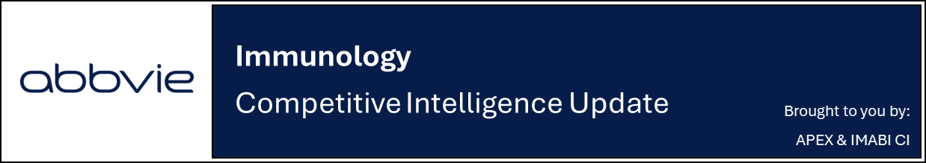

Lilly registers two new Ph2 trials in AA and vitiligo for LY4005130

Company: Eli Lilly  Drug: LY4005130 (undisclosed MoA, IV) | Date: April 16th, 2026  Source(s): CT.gov

What happened:
- Lilly registered two new Phase 2 trials, evaluating LY4005130 (undisclosed MoA, IV) in Alopecia Areata (AA) and vitiligo
  - AA: The Phase 2 24-week trial plans to recruit 60 participants, with a primary completion date (PCD) of June 2027 and a primary endpoint of SALT ≤20 at week 24
  - Vitiligo: The Phase 2 24-week trial plans to recruit 60 participants, with a PCD of May 2027 and a primary endpoint of F-VASI75 at week 24

Impact (CI PoV): MEDIUM
- The initiation of new clinical studies signals a continued expansion of Lilly’s immunology portfolio and marks their second asset in AA, following Olumiant (baricitinib, oral JAK1/2 inhibitor), and its entry into the vitiligo space, though the potential impact of the asset on the treatment paradigms remains to be determined as the MoA is undisclosed
  - CI estimates earliest approvals for both AA and Vitiligo in the US/EU in Q4 2032 based on standard assumptions
Why it matters (CI Insights in blue italics):
- Lilly is expanding its presence in AA and entering vitiligo, both increasingly competitive landscapes, with emerging assets such as Bempikibart (SC IL-7/TSLP inhibitor) and Rezpegaldesleukin (SC IL-2 Treg stimulant) in AA, as well as Litfulo (oral JAK3/TEC inhibitor) and Povorcitinib (oral JAK1 inhibitor) in vitiligo, raising the bar for clear differentiation on efficacy and convenience
Tell me more:
New trial details (AA):
Phase 2, Randomized, Multicenter, Double-Blind, Placebo-Controlled Proof of Concept Study to Investigate Efficacy and Safety of LY4005130 in Adult Participants With Severe Alopecia (AA)
Phase | Phase 2
Arms | - Experimental: LY4005130 administered intravenously (IV)  - Placebo: Placebo comparator administered intravenously (IV)
Enrollment | 60 (Estimated)
Study Start/Status | April 14, 2026 (Estimated)
Primary Completion Date | June 21, 2027 (Estimated)
Study Completion Date | October 10, 2027 (Estimated)
1EP | - Percentage of participants achieving an absolute SALT ≤20 at week 24
2EP | - Percentage of participants achieving SALT50 at week 24  - PK: Trough concentrations from baseline through week 20  - PD: change from baseline in gene expression of select genes from scalp biopsy at week 24
Key inclusion criteria | - Hair loss encompassing ≥50% and ≤90% of the scalp, as measured by SALT score  - Current episode of severe AA at least 6 months, not exceeding 4 years
Key exclusion criteria | - Previous oral JAK inhibitors use
Location(s): | - 29 locations across US, EU, UK, Canada, China and Korea

New trial details (Vitiligo):
Phase 2, Randomized, 24-Week, Multicenter, Double-Blind, Placebo-Controlled Proof-of-Concept Study to Investigate Efficacy and Safety of LY4005130 in Adult Participants With Non-Segmental Vitiligo (NSV)
Phase | Phase 2
Arms | - Experimental: LY4005130 administered intravenously (IV)  - Placebo: Placebo comparator administered intravenously (IV)
Enrollment | 60 (Estimated)
Study Start/Status | April 14, 2026 (Estimated)
Primary Completion Date | May 21, 2027 (Estimated)
Study Completion Date | September 10, 2027 (Estimated)
1EP | - Percentage of participants achieving F-VASI 75 at week 24
2EP | - Percentage of participants achieving T-VASI 75 at week 24  - PD: Change from baseline in gene expression of select genes from skin biopsy at week 24  - PK: Observed trough of LY4005130 serum concentration at week 24
Key inclusion criteria | - BSA 4% to 60%, inclusive, excluding involvement at palms of the hands, soles of the feet, or dorsal aspect of the feet  - BSA ≥0.5% on the face  - F-VASI ≥0.5 and T-VASI ≥3  - Active or stable disease at both screening and baseline
Key exclusion criteria | - JAK inhibitor therapy-naïve
Location(s): | - 35 locations across US, EU, Canada and China

For questions, please reach out to:
 | Dermatology | Rheumatology | Gastroenterology
APEX (US/PCS) | Chanda Bhat | Bethany Christmann | Luke Versten
IMABI (International/ Affiliates) | Priti Anand | Irene Knorn | Priti Anand

Invite your colleagues to inVision | Manage Email Preferences | Unsubscribe

This document contains competitive intelligence collected via AbbVie approved methods or vendors. We collect competitive intelligence consistent with industry standards and AbbVie policy. Not for commercial field use. Please reach out to CI, Legal or OEC with any questions.

